*Celestial Motion II Experiment A03*

|  |  |  |
| --- | --- | --- |
|  |  |  |
| Name |  | Lab Section |

*Objective*

* Part A: To visualize and understand the causes of eclipses.
* Part B: To understand the concept of stellar parallax.
* Part C: To investigate Kepler’s Laws.

*Materials*

Computer with Internet Access Calculator (Scientific)

Ruler

*Procedure*

|  |
| --- |
| ***Part A: Eclipses*** |

An eclipse is an astronomical event that occurs when an object is temporarily obscured, either by passing into the shadow of another body or by having another body pass between it and the viewer.

The term eclipse is most often used to describe either a solar eclipse, when the Moon's shadow crosses the Earth's surface, or a lunar eclipse, when the Moon moves into the Earth's shadow. However, it can also refer to such events beyond the Earth–Moon system: for example, a planet moving into the shadow cast by one of its moons, a moon passing into the shadow cast by its host planet, or a moon passing into the shadow of another moon. A binary star system can also produce eclipses if one star passes in front of the other.

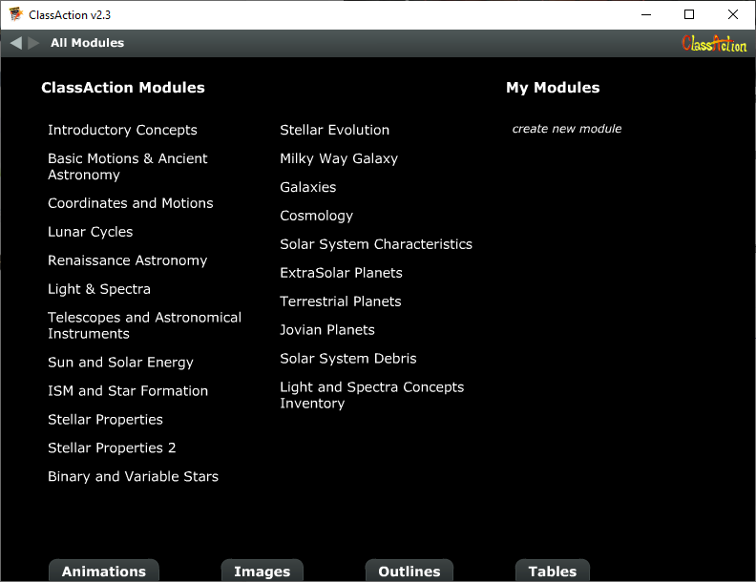This portion of the lab will explore help you visualize the conditions needed for an eclipse to occur. We will start with the *ClassAction* software that we had mentioned in the previous experiment. If needed, you can downloaded it here:

<https://astro.unl.edu/nativeapps/>

The program should also be available on the lab computers. Start by opening the *ClassAction* program and you will open to a page similar to the picture to the right.

Click on **Lunar Cycles** and then the **Animations** button at the bottom. Finally, open the simulation **Eclipse Shadow Simulator**.

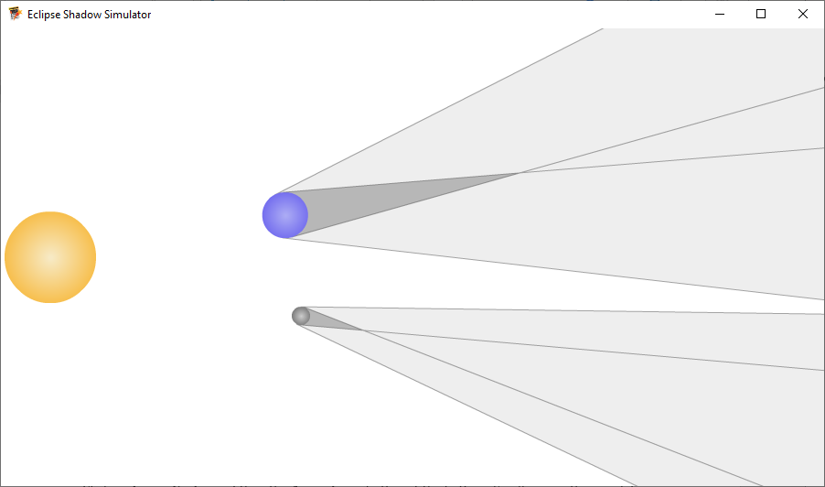

This simulation allows you to visualize systems like the Earth, Moon, and Sun and how their shadows interact with each other to cause eclipses. ***Keep in mind, this simulation is not to scale.*** Click and drag around the Earth (the blue object) and the Moon (the gray object) in order to see how their distance from the Sun changes the shape of their shadows. Position the Earth and Moon for a solar eclipse to occur and then for a lunar eclipse.

1. In the space below, draw the relative positions of the Sun, Earth, and Moon for both a solar eclipse and a lunar eclipse.

|  |  |  |
| --- | --- | --- |
| **Solar Eclipse** |  | **Lunar Eclipse** |

1. The angular size of an object is the angle it appears to span in your field of vision. This can be calculated with the following equation:
   1. The Moon’s diameter is 3.48 x103 km and the distance between the Earth and the Moon is, on average, 3.84 x105 km. The Sun’s diameter is 1.39 x106 km and the distance between the Earth and Sun is, on average, 1.50 x108 km. Calculate the angular size of the Moon and the angular size of the Sun from the point of view of an observer on Earth.

|  |
| --- |
| Enter Answer Here: Moon |

|  |
| --- |
| Enter Answer Here: Sun |

* 1. Based on your answers above, if the Moon’s physical diameter is much smaller than the Sun’s physical diameter, how is it that the Moon can block the entirety of the Sun during a total solar eclipse?

|  |
| --- |
| Enter Answer Here |

* 1. To help with the previous question, consider the size and distance ratios of the Sun compared to the Moon. Calculate the ratio of the size of the Sun compared to the Moon (Sun size/Moon size) and the distance ratio (Sun distance/Moon distance). What do you notice about these ratios? Are they the same? Similar? Different? Wildly different?

|  |
| --- |
| Enter Answer Here |

* 1. Why do annular solar eclipses sometimes occur instead of total solar eclipses?

|  |
| --- |
| Enter Answer Here |

|  |
| --- |
| ***Part B: Stellar Parallax*** |

Parallax is a displacement or difference in the apparent position of an object viewed along two different lines of sight. Parallax is measured by the angle between those two lines. Nearby objects have a larger parallax than more distant objects when observed from different positions, so parallax can be used to determine distances. Astronomers use the principle of parallax to measure distances to nearby stars. Here, stellar parallax is created by the relative motion from the orbit of the Earth around the Sun.

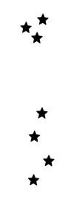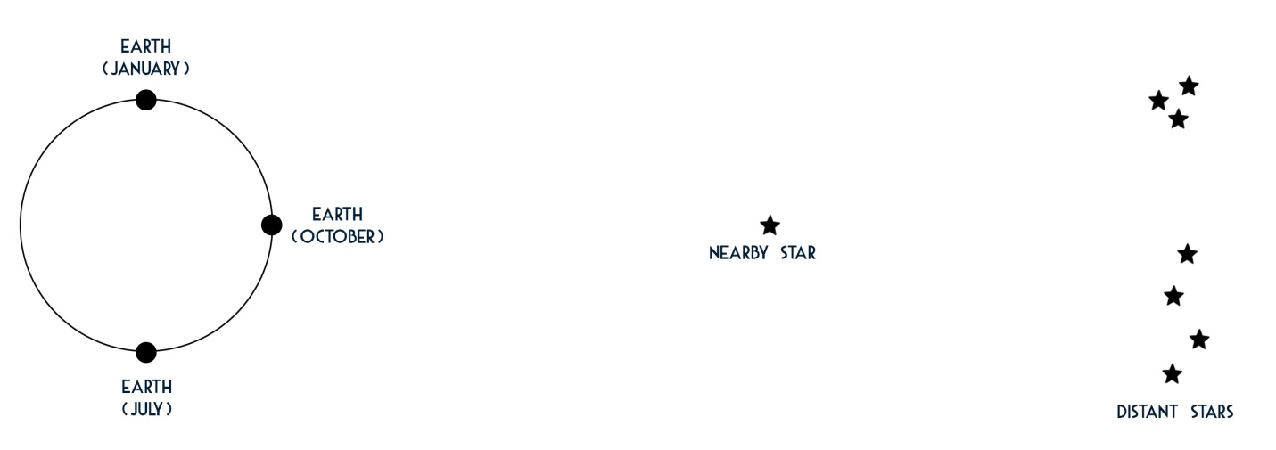

1. Consider the diagram above:
   1. In October, you are observing the night sky. Use the *Insert 🡺 Shape* feature in Wordto draw a straight line from Earth in October, through the “Nearby Star”, out to the “Distant Stars”. In the image of the sky shown to the below, insert a star shape at the position of the “Nearby Star” as viewed in October.



* 1. Repeat the ‘part a’ procedure for the “Nearby Star” as viewed in January.



* 1. Repeat the ‘part a’ procedure for the “Nearby Star” as viewed in July.
  2. Describe how the “Nearby Star” appears to move in the night sky over the course of a year. This motion is called **stellar parallax**.

|  |
| --- |
| Enter Answer Here |

* 1. In the first diagram, imagine a new star closer to Earth (between Earth and the “Nearby Star”). Compared to the “Nearby Star”, throughout the course of a year, will this closer star appear to move *more* or *less* through the night sky (more parallax or less parallax)? Why?

|  |
| --- |
| Enter Answer Here |

* 1. In the first diagram, imagine a new star further from Earth (between the “Nearby Star” and the “distant stars”). Compared to the “Nearby Star”, throughout the course of a year, will this closer star appear to move *more* or *less* through the night sky (more parallax or less parallax)? Why?

|  |
| --- |
| Enter Answer Here |

* 1. Astronomers know that the distance between the Earth and the Sun averages 1.50 x108 km. How can astronomers use the observed stellar parallax, and a little knowledge of geometry, to measure the distance to nearby stars? *(Remember that the distance between two positions in the night sky is measured in angular separation.)*

|  |
| --- |
| Enter Answer Here |

* 1. Many ancient Greek astronomers understood the concept of parallax, and that objects should appear to shift if you change your viewing position. However, they were unable to detect stellar parallax, which is why they kept the notion of a geocentric Universe for a long time. Why were the ancient Greeks not able to detect stellar parallax?

|  |
| --- |
| Enter Answer Here |

* 1. Given the relationship between parallax and the distance of faraway objects such as stars, describe why some ancient Greek astronomers thought Earth had to be the stationary center of the Universe.

|  |
| --- |
| Enter Answer Here |

**Kepler’s Laws**

1. The orbital paths of the planets are elliptical with the Sun at one focus of the ellipse.
2. An imaginary line connecting the Sun to any planet sweeps out equal areas of the ellipse in equal amounts of time.
3. The square of a planet’s orbital period is proportional to the cube of its semi-major axis.

|  |
| --- |
| ***Part C: Kepler’s Laws*** |

In the early 1600s, Johannes Kepler, using observations and data from astronomer Tycho Brahe, first published his three laws of planetary motion. These laws were empirically determined with any references to any underlying physical theory. They were determined by examining the shape and speed of planetary orbits. Nearly 70 years later it was shown by Isaac Newton, while formulating his theory of gravitation, that Kepler’s Laws are a direct consequence of Newton’s Laws.

**Kepler’s First Law** *- The orbital paths of the planets are elliptical with the Sun at one focus of the ellipse.*

Kepler’s main achievement with his empirical laws was in showing that the orbits of the planets were best described by ellipses. Since the ancient Greek astronomers, orbits based upon circles and epicycles were the accepted theory for planetary orbits. An ellipse appears as a somewhat flattened circle.

We will return to the *NAAP Labs* program that we had used in the previous experiment. Open the program and navigate to *5. Planetary Orbits*. Open the simulation **Planetary Orbit Simulator**. On the left side of the applet, choose the tab for **Kepler’s 1st Law**.

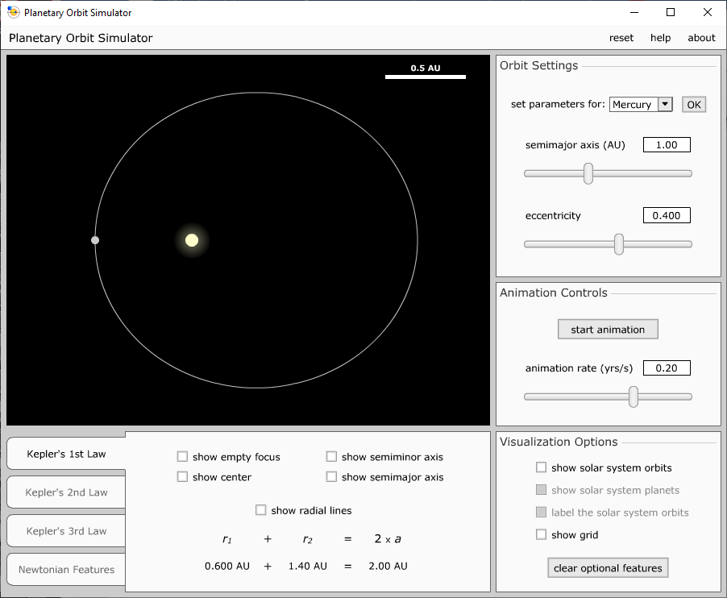

1. Select ‘Mercury’ from the drop-down menu in the top right and click OK. Check all 5 options in the bottom middle of the screen: ‘show empty focus’, ‘show semimajor axis’, etc...
2. Click and drag the planet (the gray dot) around on its orbit. Place the planet at its perihelion position, all the way on the left side of the orbit. At this position, the value for *r1* is the distance from the planet to the Sun in AU (this is found at the bottom of the screen). In the table below record the perihelion distance and the semimajor axis for the planet.
3. Move the planet to its aphelion position on the far right of the orbit. Here, *r1* is the aphelion distance. Record this value in the table below.
4. Repeat steps 1-3 above for both Earth and Pluto.

|  |  |  |  |  |
| --- | --- | --- | --- | --- |
| **Planet** | **Eccentricity** | **Semimajor Axis**  **(AU)** | **Perihelion Distance**  **(AU)** | **Aphelion Distance**  **(AU)** |
| Mercury |  |  |  |  |
| Earth |  |  |  |  |
| Pluto |  |  |  |  |

In the table below, again write in your perihelion and aphelion distance for the Earth. If you subtract the perihelion distance from the aphelion distance you can find how much closer the Earth is to the Sun when at perihelion as compared to aphelion. Convert this distance to miles (hint: 1 AU = 9.296 x107 miles).

|  |  |  |  |  |
| --- | --- | --- | --- | --- |
| **Planet** | **Perihelion Distance**  **(AU)** | **Aphelion Distance**  **(AU)** | **Difference**  **(Aphelion – Perihelion)**  **(AU)** | **Difference**  **(Aphelion – Perihelion)**  **(miles)** |
| Earth |  |  |  |  |

1. How many miles closer to the Sun is the Earth when at perihelion vs. aphelion?

|  |
| --- |
| Enter Answer Here |

1. Look up online what months of the year we are closest to and farthest from the Sun.

|  |
| --- |
| Closest –  Farthest - |

1. Increase the eccentricity of the orbit. What happens to shape of the orbit? What do you notice about the about speeds at perihelion and aphelion for large eccentricity?

|  |
| --- |
| Enter Answer Here |

1. What shape is an orbit with an eccentricity of zero?

|  |
| --- |
| Enter Answer Here |

**Kepler’s Second Law** - *An imaginary line connecting the Sun to any planet sweeps out equal areas of the ellipse in equal amounts of time.*

While Kepler’s 2nd Law is probably the most difficult of his laws to understand or visualize, this portion of the lab will investigate several aspects of this law. The main significance of this law is that planets will orbit faster when they are closer to the Sun and orbit slower when farther away. Planetary orbit speeds are NOT constant, but instead change with time.

1. Clear the optional features from step 1 in the previous portion of the lab, and select the **Kepler’s 2nd Law** tab.
2. Set the semimajor axis to 1.00 AU and the eccentricity to 0.5 by using the sliders or by typing the values into the appropriate boxes.
3. Click the ‘Start Animation’ button and then click on the ‘Start Sweeping’ button. When the planet is near the opposite side of its orbit click the ‘Start Sweeping’ button again. Try to obtain two sections that are on fairly opposite sides of the orbit. If needed, use the ‘Animation Rate’ slider to slow down how fast the planet orbits.
4. Click the ‘Pause Animation’ button.
5. If you click on each of the two areas, what do you notice about the ‘Sweep Area’ that is given at the bottom of the screen?

|  |
| --- |
| Enter Answer Here |

1. If you click and drag around the sweep areas, where is the sweep segment the thinnest? Where is it the widest? What are the names for these two positions in a planets orbit?

|  |
| --- |
| Enter Answer Here |

**Kepler’s Third Law**­­ - *The square of a planet’s orbital period is proportional to the cube of its semi-major axis.*

Kepler’s 3rd Law tells us that more distant planets orbit the Sun at slower average speeds, obeying a precise mathematical concept.

where *P* is the planet’s orbital period in years, *a* is its semimajor axis (or average distance from the Sun) in astronomical units (AU), and *k* is a constant. *k* is not a universal constant like the speed of light or Newton’s Gravitational Constant *G*. Rather, *k* depends on the particular body that is being orbited (e.g., the Sun).

For this portion of the lab, it is up to you to determine the value of *k* for our solar system. We can take the above equation and solve it for *k*:

1. Use your book, or various internet sources, to look up and record the orbital period and the semimajor axis for each of 4 random planets in our solar system. Be sure to use units of **years** and **AUs**.
2. Calculate *k* for each of the planets.

|  |  |  |  |
| --- | --- | --- | --- |
| **Planet** | **Period – P**  **(years)** | **Semimajor Axis – a**  **(AU)** | ***k*** |
|  |  |  |  |
|  |  |  |  |
|  |  |  |  |
|  |  |  |  |

1. What do you notice about *k* for each of the planets?

|  |
| --- |
| Enter Answer Here |

*This lab manual was written by Justin Mason, Old Dominion University, and copied to be made available on this website by Corey Sargent, Old Dominion University, Fall 2021*